Angel Umi Heri

Installation and Navigation of VS Code.

**Question 1.**

Steps and Screenshots of Visual Studio Code Installation:

1. Download VS Code:

   - Visit the Visual Studio Code download page: [VS Code Download] (https://code.visualstudio.com/Download).

   - Select the appropriate version for Windows and download the installer.

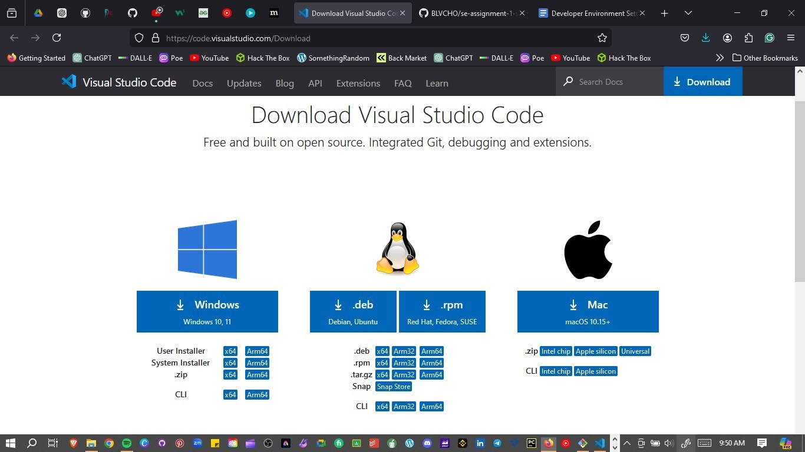

2. Installation Process:

   - Run the downloaded installer.

   - Follow the installation wizard, accepting the license agreement and choosing the installation location.

   - Select additional tasks such as adding to PATH and creating a desktop icon

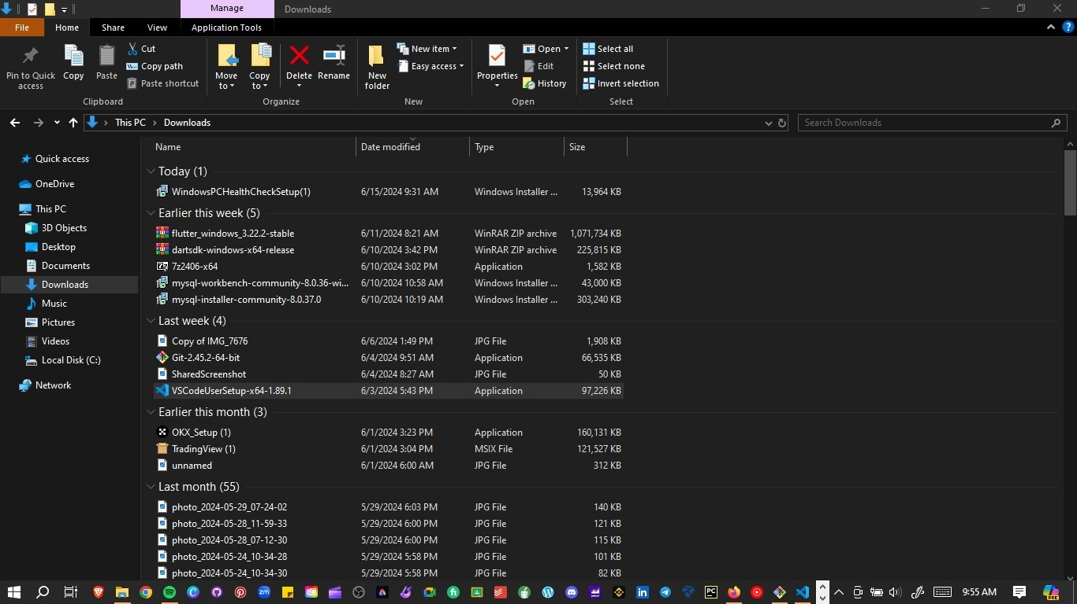

3. First Launch and Setup:

   - Launch VS Code and install recommended extensions like Python, GitLens, and Docker

**Question 2.**

An optimal coding environment can significantly enhance productivity. Some initial settings and configurations that are paramount in this are:

1. **Extensions:** install relevant extensions to enhance functionality. For example, GitLens for enhancing integration with Git.
2. **Themes and fonts:** a visually appealing environment can positively enhance your coding experience.
3. **Settings sync:** so as to synchronize your settings across different machines.
4. **Custom shortcuts:** create shortcuts for common tasks like finding, replacing and renaming files.
5. **Format on save:** enable this option to automatically format your code when saving.
6. **Window Title Customization:** customize the window title to display relevant information.
7. **Sidebar position:** choose whether the sidebar should be on the left or the right.
8. **File icons:** install an extension for file icons to make navigation easier.

**Question 3.**

Main components of the VS Code user interface:

1. **Editor area:** the central place where you edit your files.
2. **Side bar:** contains various views such as **the explorer,** which helps you navigate your projects and files.
3. **Status bar:** located at the bottom, it provides information about the currently opened project and the files you are editing.
4. **Activity bar:** positioned on the far left, it allows you to switch between different views (like the explorer, source control etc.).

**Question 4.**

The **command palette** is a powerful tool that allows you to execute various commands and actions within the editor.

You can access it by using the shortcut **ctrl+shift+p** on windows.

Common tasks you can perform using the command palette:

1. Quickly opens a specific file in the editor.
2. Find specific symbols within your code.
3. Execute predefined tasks e.g. debug related to your project.
4. Install, update or remove VS Code extensions.

**Question 5.**

Role of extensions.

1. Enhance functionality through adding languages, debuggers and tools to VS Code.
2. Extensions are used to tailor your environment, where you can install extensions that suit your workflow.

Finding and installing extensions.

1. Open the **extensions** view by using the shortcut **ctrl+shift+x.**
2. Search for an extension…e.g. SQL server.
3. Click **Install.**

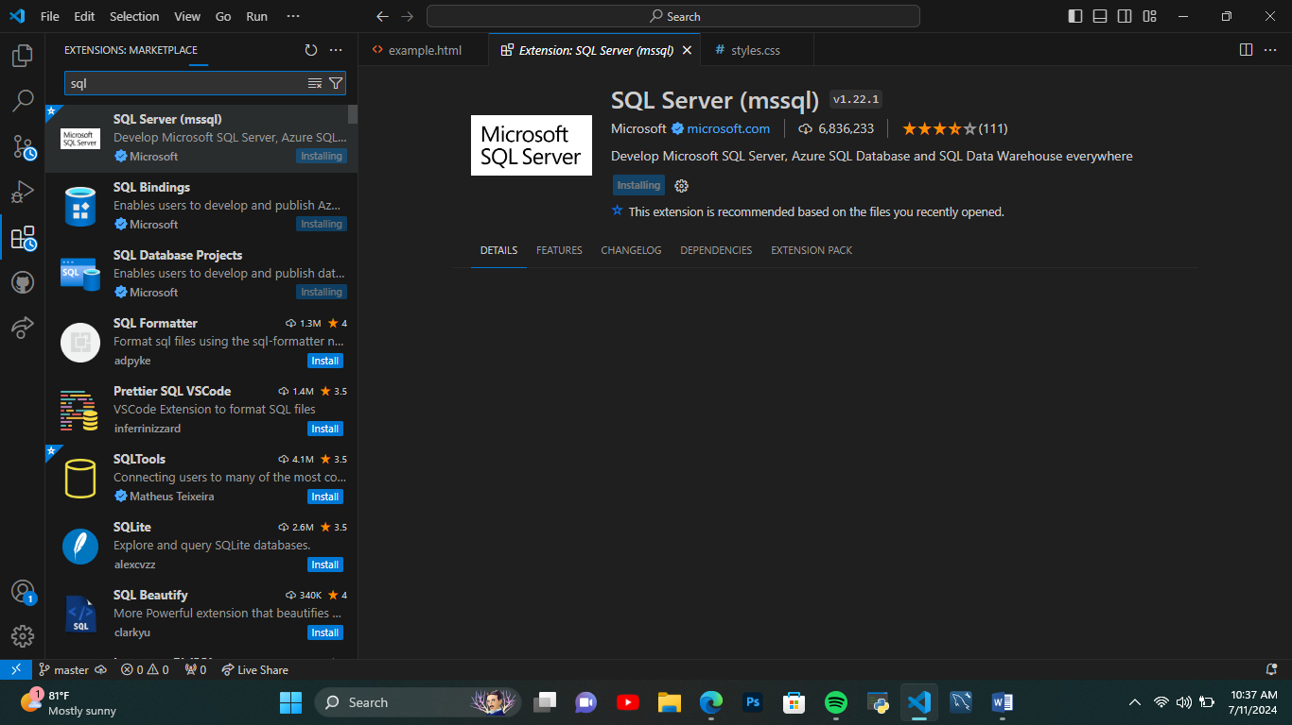

Examples of essential extensions for web development:

* Javascript (ES6) code snippets.
* CSS peak
* Auto Close tag.

**Question 6.**

How to open and use the integrated terminal.

1. From the menu, go to **terminal > New Terminal.**

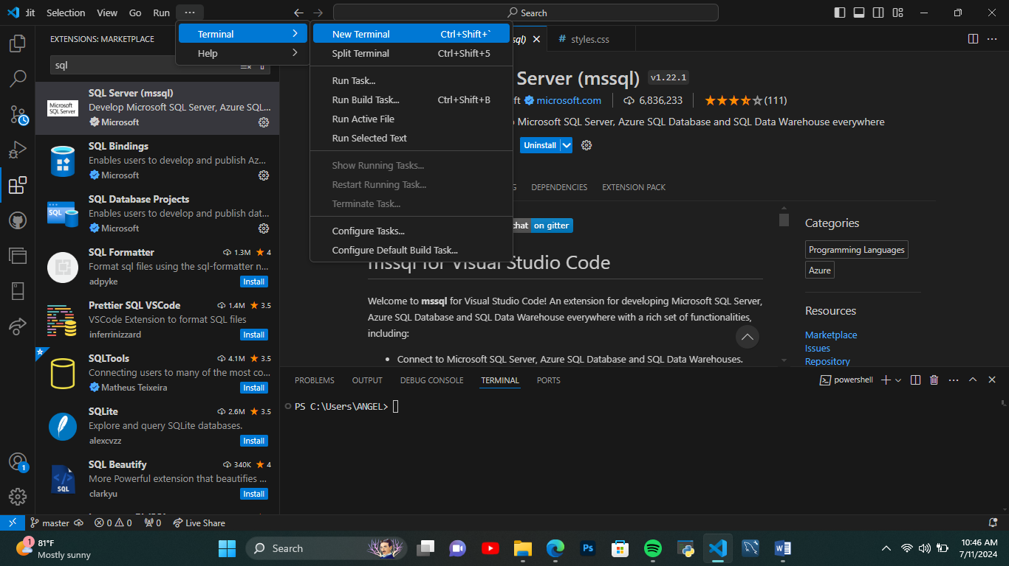

1. Once the terminal is open, you can run commands for example creating directories (mkdir), managing Git (git commands) and more.

Advantages of using the integrated terminal compared to an external terminal.

* Provides seamless integration, since it is tightly integrated with vs code. This allows you to work directly with your project files.
* It supports features like links to workspace files and error detection, thus it is easy to navigate to files or folders by clicking on them in the terminal output.
* You can run commands directly within vs code without switching to an external terminal.
* You can choose from various shells and configure them to your preference.
* Vs code allows you to create multiple terminal instances, split them into groups and manage them efficiently. This facilitates multitasking.

**Question 7.**

Creating a new folder.

Open VS code.

Click the **file** menu, select **open folder.**

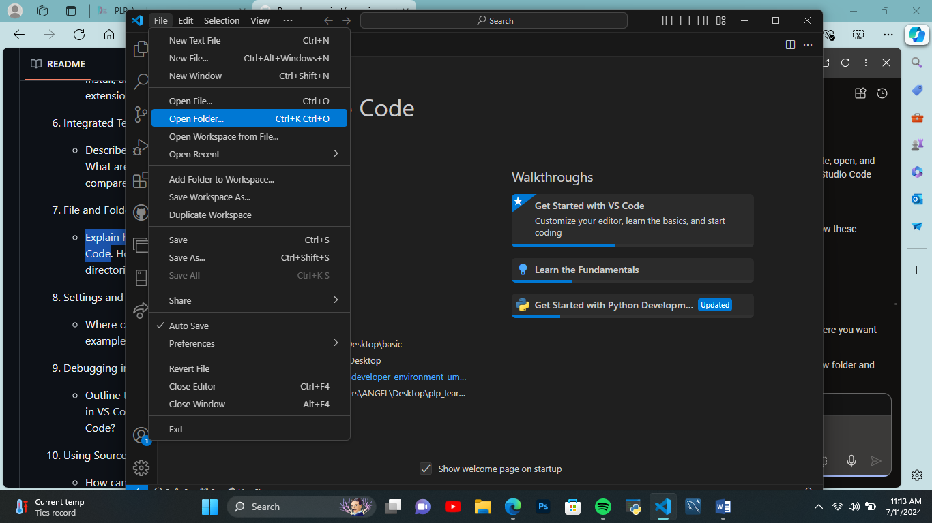

Choose the location where you want to create the folder.

Enter a name for the new folder and press **Enter.**

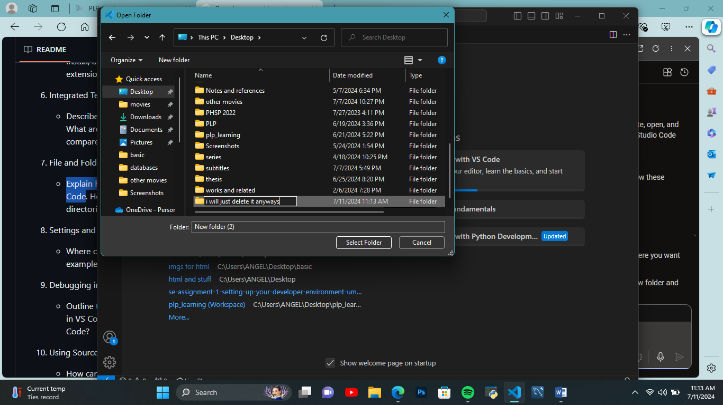

Opening a folder.

Click the **File** menu, select **open folder.**

Managing files and folders.

To add more folders to your workspace, use gestures like **add folder to workspace** or drag and drop folders.

To remove a folder, use the **remove folder from workspace** context menu.